 **Enterprise Infrastructure Project**

**CSI345L – Computer Networks**

Submitted to:

Dr. Gaby Abou Haidar

by:

Fouad Dakhoul (12210449)

Youssef Chayeb (12210624)

Mohamad Madi (12203006)

Yaakoub khalil (12200055)

**Objectives**

1. Create an Enterprise network that simulates a real enterprise setup.
2. Head office to Branch office connectivity.
3. VLSM – VLANS – Router and Switch security.
4. Using Packet Tracer tool.

**Specifications**

1. Enterprise network, simulating a real enterprise setup.
2. Head Office, and Branch office, interconnected using back to back secure routers throughout the ISP link Several offices (ex: Management, IT, Users, Servers etc..) in each location.

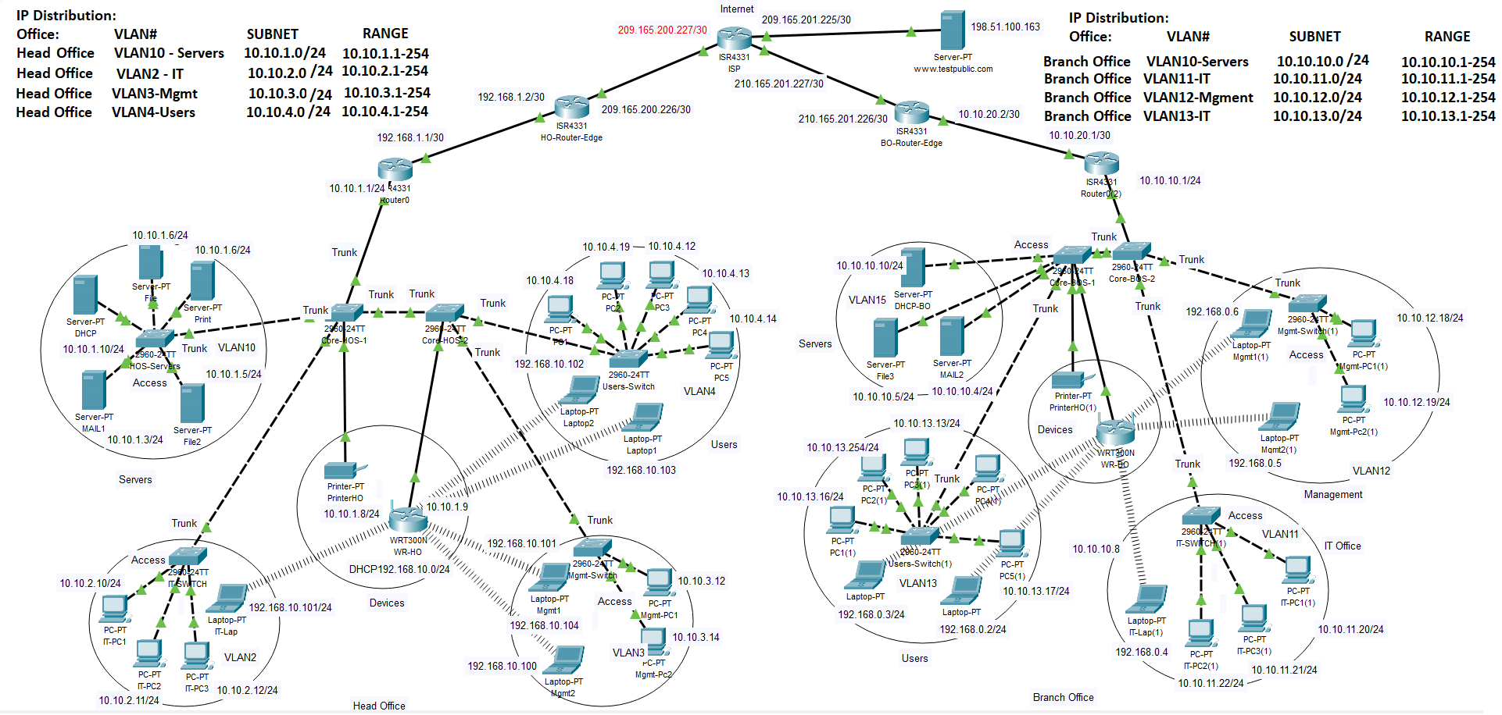**Design**

**Results and Conclusion**

Simulating a real Enterprise infrastructure setup, using Packet Tracer, provided us the mean and hands on experience, about how a real-world setup would be configured and utilized. This project gave us the opportunity to work and achieve a high-level exposure and experience in the world of networking.